**Returning to School in September**

Please note that our return date to School in September is Tuesday 3rd September. Our inset days for the 2019/2020 school year are listed below.

**Inset Days for the 2019-2020 School Year**

Friday 30th August – Admin Day

Monday 2nd September 2019

Monday 4th November 2019

Monday 24th February 2020

Monday 1st June 2020

**Twycross Zoo**

The Reception, Year 1 and Year 2 classes all went on a visit to Twycross Zoo earlier this week. Everyone had a great time, although it was very hot and very tiring! We saw so many interesting animals including the new tigers, who had only just moved in! The behaviour of all of the children was fantastic and they all had a lovely day. Well done, everyone!

**Year 6 Trip**

Year 6 enjoying their end of Forest Glade Trip to ‘Megazone’l!

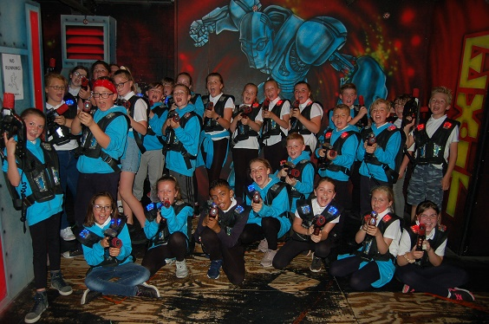

**Golden Ticket Reward Trip to Jimmy Beans**

A good time at Jimmy Beans for the Golden Ticket Rewards

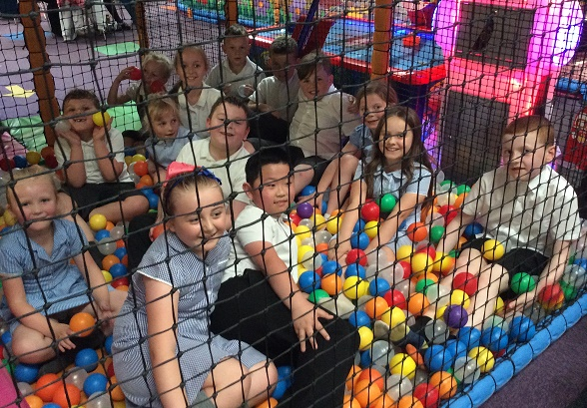

**The Big Gig**

Just a reminder that ‘the big gig’ will now be happening on **Tuesday (23rd July)**, instead of today (Friday). After a day of rain and grey skies, we have definitely made the right decision!

**Breakfast Club**

If you would like to make a booking for Breakfast Club in September, the booking system on ParentPay will be open between the 27th -29th August for the week school returns, Tuesday 3rd September.

**Welcome to our newsletter…**

**Last day of Term**

Wednesday 24th July 2019

**Next Week**

**Monday 22nd** Y6DARE Graduation Y6 2.30

**Tuesday 23rd** Y6 Leavers Assembly 2.45

**Tuesday 23rd** Guitar Club 3.35-4.35

**Tuesday 23rd** Clarinet Club 3.35-4.35

**Tuesday 23rd** ‘The Big Gig’ Summer Concert 6.30-8.30

**Latest**

**Letters This Week:**

* Mystery Trip (Y4 in September)

**Treasure Island**

Earlier this week Year 5 and Year 6 performed the end of year production of Treasure Island. The Year 5s provided most of the singing and were amazing; we can’t wait to see what you do next year! The Year 6s were the actors and every single one of them performed brilliantly. There were many memorable performances and the audience really enjoyed the show. I know how hard the Year 6 children worked on their performance and I was so pleased to see how well they did!

Mr Paramore, Head of School

**Year 6 SATs Results**

|  |  |  |
| --- | --- | --- |
| **% at National Standard** | **Forest Glade** | **2019 National** |
| Reading | 83% | 73% |
| Writing | 93% | 78% |
| Maths | 97% | 79% |
| **RWM combined** | **79%** | **65%** |
| GPS | 97% | 78% |

We are really pleased with the SATs results that our Year 6 children have achieved. They have had a brilliant few weeks as their time at Forest Glade comes to an end – impressing us with their academic achievements and wowing us with their play too! Well done, Year 6!

Mr Paramore, Head of School

**Healthy Snacks**

As you may know, all of our FS and Key Stage 1 children receive free fruit everyday as a healthy snack. Usually the children have this snack mid-morning. Children in Key Stage 2 are not provided with daily fruit, but we are happy for parents to send fruit in themselves, if they wish. Some children have this fruit in their lunchboxes and some keep it separate. Either way, the children are encouraged to have their fruit at break time every day. I would just like to remind everyone that other snacks (e.g. crisps, biscuits, etc.) are not allowed. Thank you for your cooperation with this.

Mr Paramore, Head of School



**0**

**School Library**

Please note that the library will be closed for the after-school session on Tuesday 12th & for the morning and after-school sessions on Wednesday 13th December. Apologies for any inconvenience.