**Welcome Back!**

The summer holidays have finished and we have just come to the end of our first week of the new school year.  I would like to welcome everyone back to Forest Glade and say a big 'hello' to all the new children who have started with us too.  Everyone looks very smart in their uniforms and we have made a super start to the new year.  I would also like to take this opportunity to tell you about some of the exciting things happening in school.

First of all, I want to tell you a bit about our school curriculum.  We have always tried to make our curriculum fun and varied, making use of trips and visitors, and encouraging creativity.  This year, we are hoping to build on this and find even more ways of introducing the 'wow' factor.  Already, within the first week, Y6 have been on a trip to a local stables and several other classes have created big pieces of art.  Next week, Y4 are launching their new topic with a mystery visit.  They are heading off on a coach, but they don't know where they are going to, or why they are going there!

I also want to let you know that we are going to be encouraging reading more than ever this year.  As part of this, all our topics will be linked to books.  We have also begun redecorating the corridors to reflect some of our favourite children's books.  The main KS1 corridor is now a forest, filled with characters from Julia Donaldson's books.  The main KS2 corridor is now Hogwarts, the magical school from the Harry Potter books.  There are even more developments to come too!  Reading is so important; the more we can encourage reading at home and at school, the better the children's learning will be.  As always, thank you for your support with reading.

Mr Paramore – Head of School

**Coffee Morning**

Our weekly coffee mornings will start again on Tuesday 10th September 8.50am-10.00am in the Community Room. Everyone is welcome including younger siblings. It’s a great opportunity to come and meet other parents and carers and have a chat over a coffee. Feel free to stay after you have dropped your children off!

**Year 6 Trip**

As part of their ‘War Horse’ topic Year 6 visited Carnarvon Cottage Riding School & Livery this week. Everyone had a great time learning how to groom and care for the horses and even helped with ‘mucking out’.

Mrs Brandrick-Smith

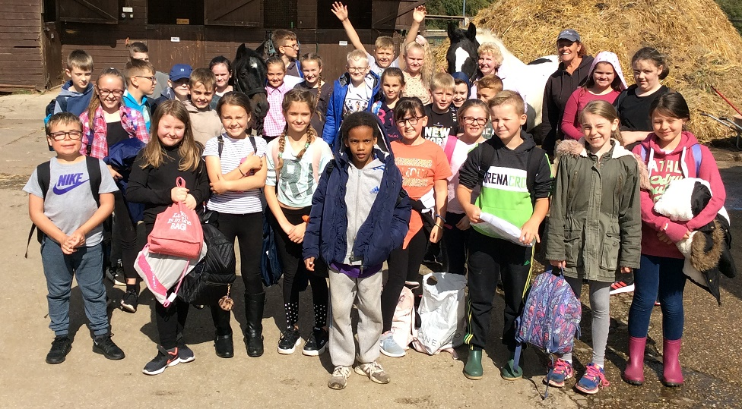

**Welcome to our newsletter…**

**Last day of Half Term**

**Friday 18th October 2019**

**Inset Days 2019/2020**

Monday 4th November 2019

Monday 24th February 2020

Monday 1st June 2020

**Next Week**

**Monday 9th** Y4 Swimming – Don’t forget your kit!

**Monday 9th** Fencing Club Y3/Y4 3.35-4.30

**Tuesday 10th** Guitar Club 3.35-4.35

**Tuesday 10th** Clarinet Club 3.35-4.35

**Tuesday 10th** Cheerleading Club KS2 3.35-4.30

**Wednesday 11th** Boccia Club Y1/Y2 3.35-4.30

**Thursday 12th** Year 4 – Mystery Trip

**Thursday 12th** Dodgeball Club KS2 3.35-4.30

**Friday 13th** School Class Photographs

**Friday 13th** Non-Contact Boxing Club Y5/Y6 3.35-4.30

**September**

**Wednesday 25th – Friday 27th** PGL Residential Y6

**Latest**

**Letters This Week:**

* School Swimming Y4
* Fencing Club Y3/4
* Cheerleading Club KS2
* Boccia Club Y1/2
* Dodgeball Club KS2
* Non-contact Boxing Club Y5/6

**Staffing News**

We are delighted to welcome Miss Dowsing who has joined our teaching team in the Reception Class.

**Head Lice**

We have recently had a few instances of head lice in school. May we remind parents to check your child’s hair once a week and be extra vigilant. If using a treatment on your child please ensure that this is followed up with a repeat application one week later. Any children with long hair should have this tied up during school time.

**Water is Cool in School**

Please ensure you are sending your child into school with only plain water in their water bottle. Sweetened waters or juice are not acceptable substitutes for water. Spilt water can be easily mopped and will dry quickly when spilt on books and/or clothing.

**After School Sports Clubs**

You should have received a text confirming whether your child has a place on our after school sports clubs which start w/c 9th September. We currently have places available in Y1/2 Boccia, Y5/6 Non contact-boxing & Key Stage 2 Cheerleading. If your child would like to join any clubs please speak to a member of the office staff.



**School Group Photos (not individual)**

Group class photos are being taken on Friday 13th September. Can you please send your child in looking as smart as possible and in their school uniform (as usual!!).